**Database Programming with SQL 8-2: Count, Distinct, NVL**

**Vocabulary**

COUNT - Returns the number of non-null values in the expression column

DISTINCT - The keyword used to return only non-duplicate values or combinations of non-duplicate values in a query.

COUNT(DISTINCT expression) - Returns the number of unique non-null values in the expression column.

**Try It / Solve It**

1. How many songs are listed in the DJs on Demand D_SONGS table?

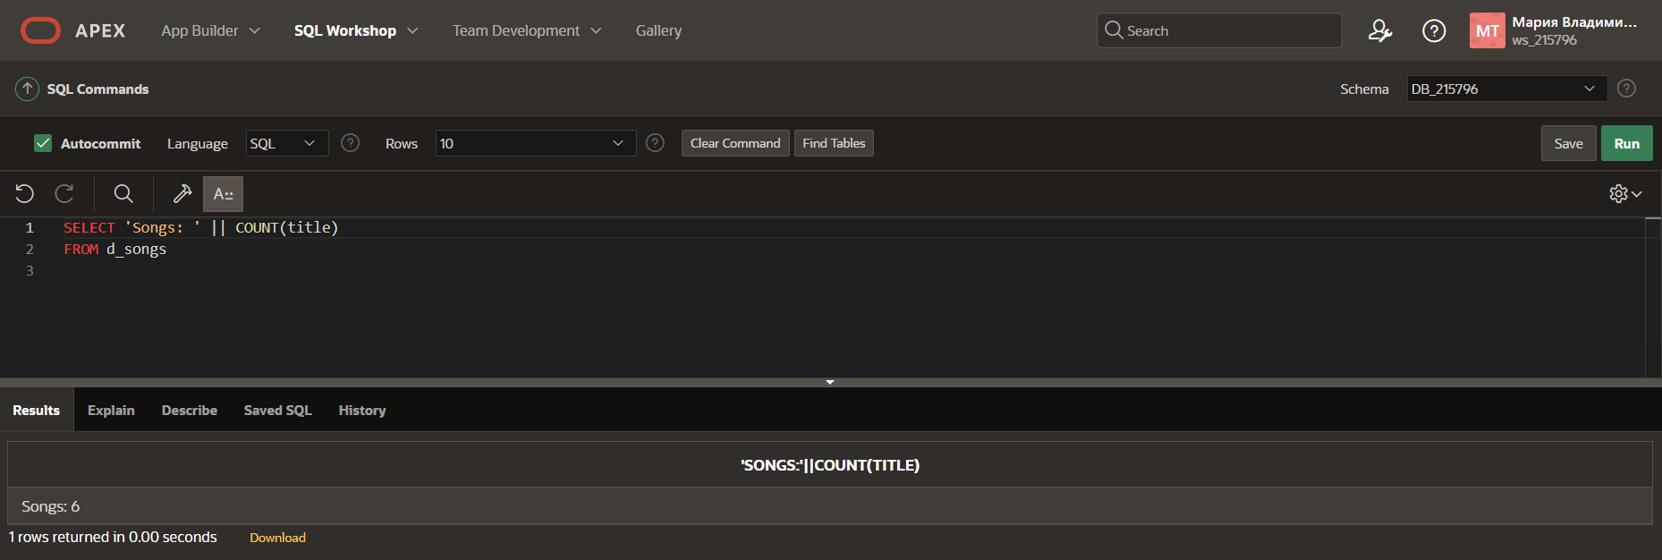

1. In how many different location types has DJs on Demand had venues?

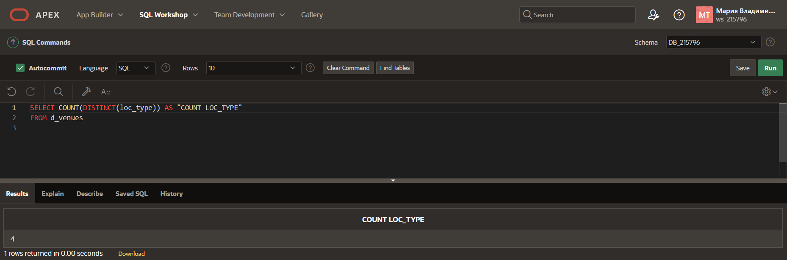

1. The d_track_listings table in the DJs on Demand database has a song_id column and a cd_number column. How many song IDs are in the table and how many different CD numbers are in the table?

1. How many of the DJs on Demand customers have email addresses?

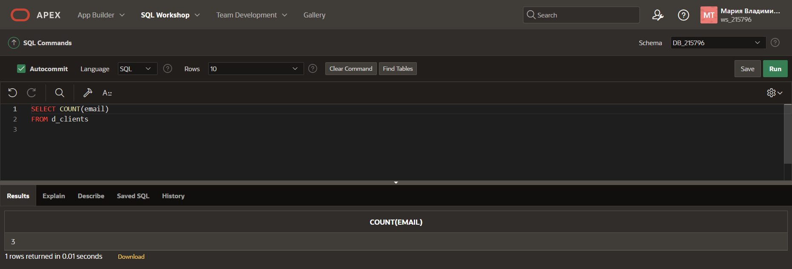

1. Some of the partners in DJs on Demand do not have authorized expense amounts (auth_expense_amt). How many partners do have this privilege?

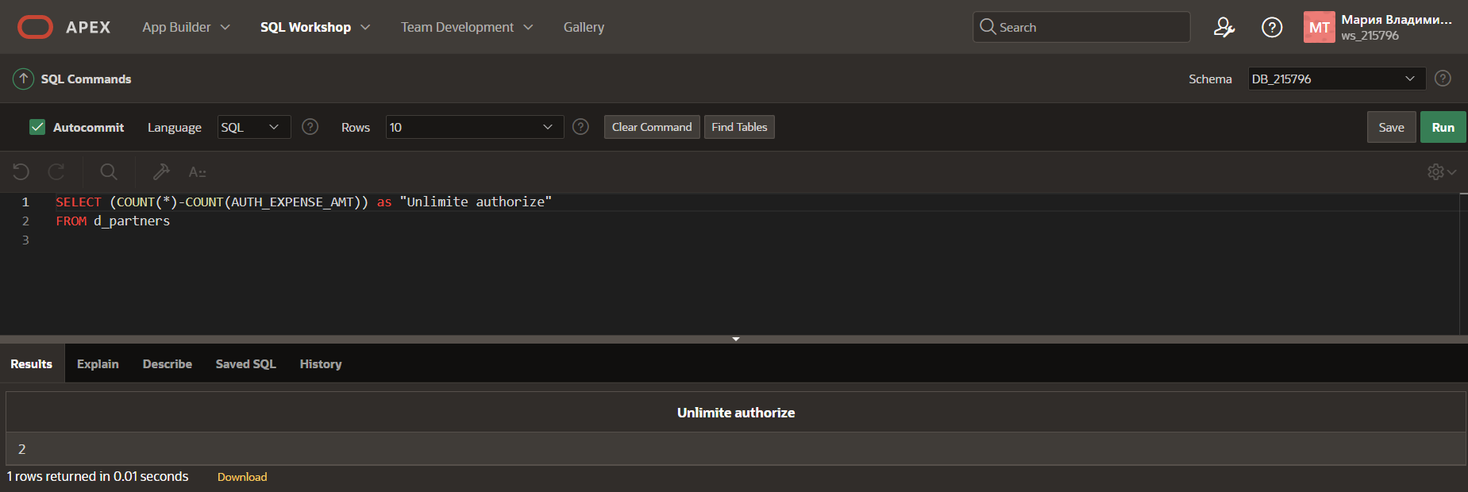

1. What values will be returned when the statement below is issued?

SELECT COUNT(shoe_color), COUNT(DISTINCT shoe_color)

FROM shoes;

**Count of all shoes and count of all unique colors**

1. Create a query that will convert any null values in the auth_expense_amt column on the DJs on Demand D_PARTNERS table to 100000 and find the average of the values in this column. Round the result to two decimal places.
2. Which statement(s) is/are True about the following SQL statement:

SELECT AVG(NVL(selling_bonus, 0.10))

FROM bonuses;

__F__ a. The datatypes of the values in the NVL clause can be any datatype except date data.

__T__ b. If the selling_bonus column has a null value, 0.10 will be substituted.

__T__ c. There will be no null values in the selling_bonus column when the average is calculated.

__F__ d. This statement will cause an error. There cannot be two functions in the SELECT

statement.

9. Which of the following statements is/are TRUE about the following query?

SELECT DISTINCT colors, sizes

FROM items;

__F__ a. Each color will appear only once in the result set.

__F__ b. Each size will appear only once in the result set.

__T__ c. Unique combinations of color and size will appear only once in the result set.

__F__ d. Each color and size combination will appear more than once in the result set.